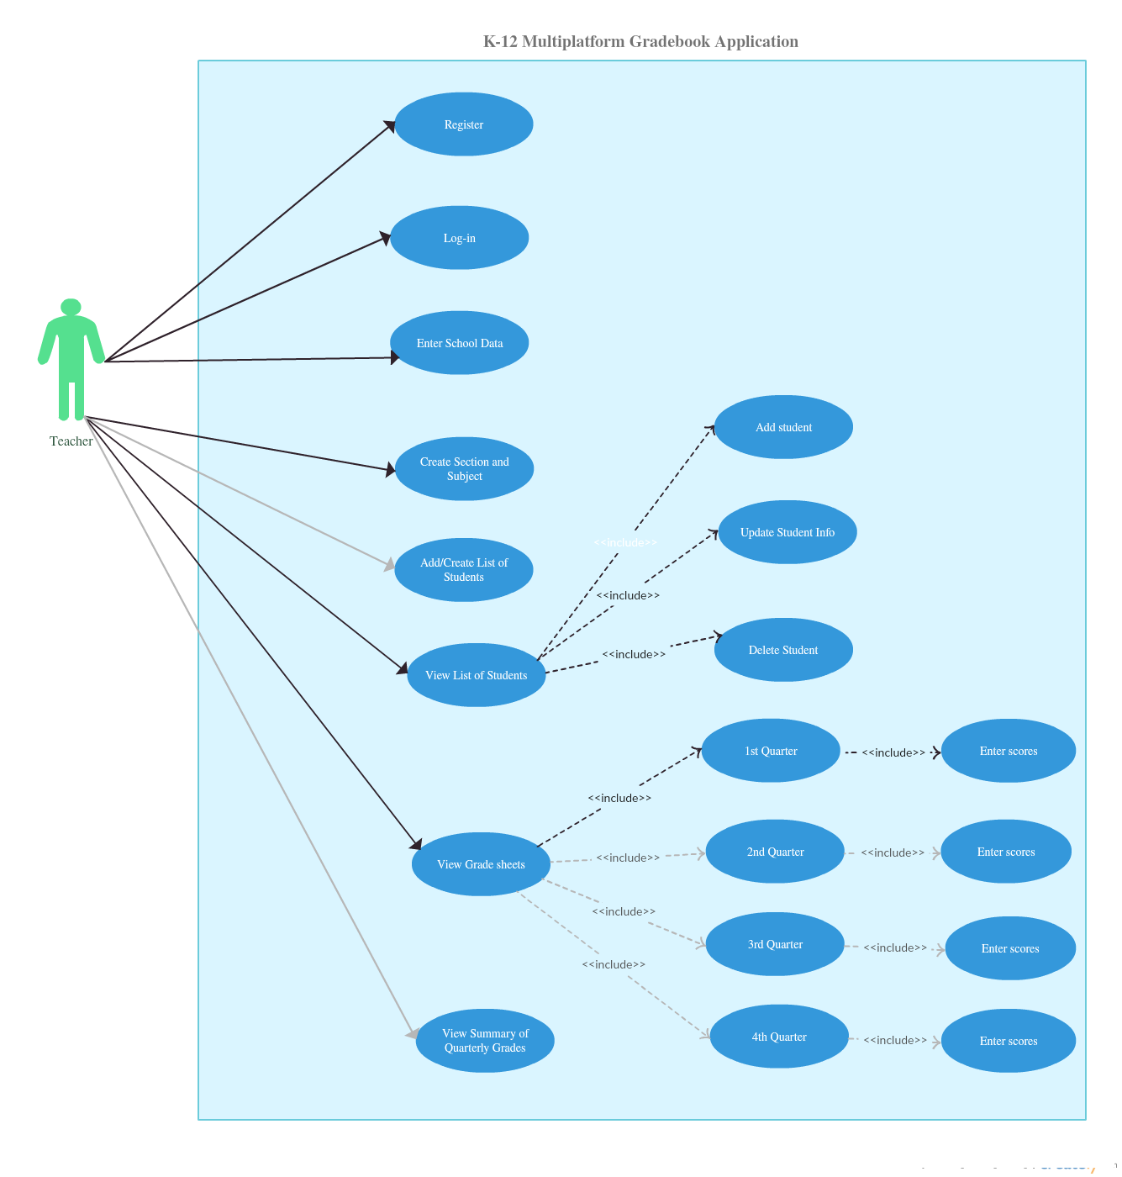

**Figure 1**. Use Case Diagram Of K-12 Multiplatform Gradebook Application (Desktop Platform)

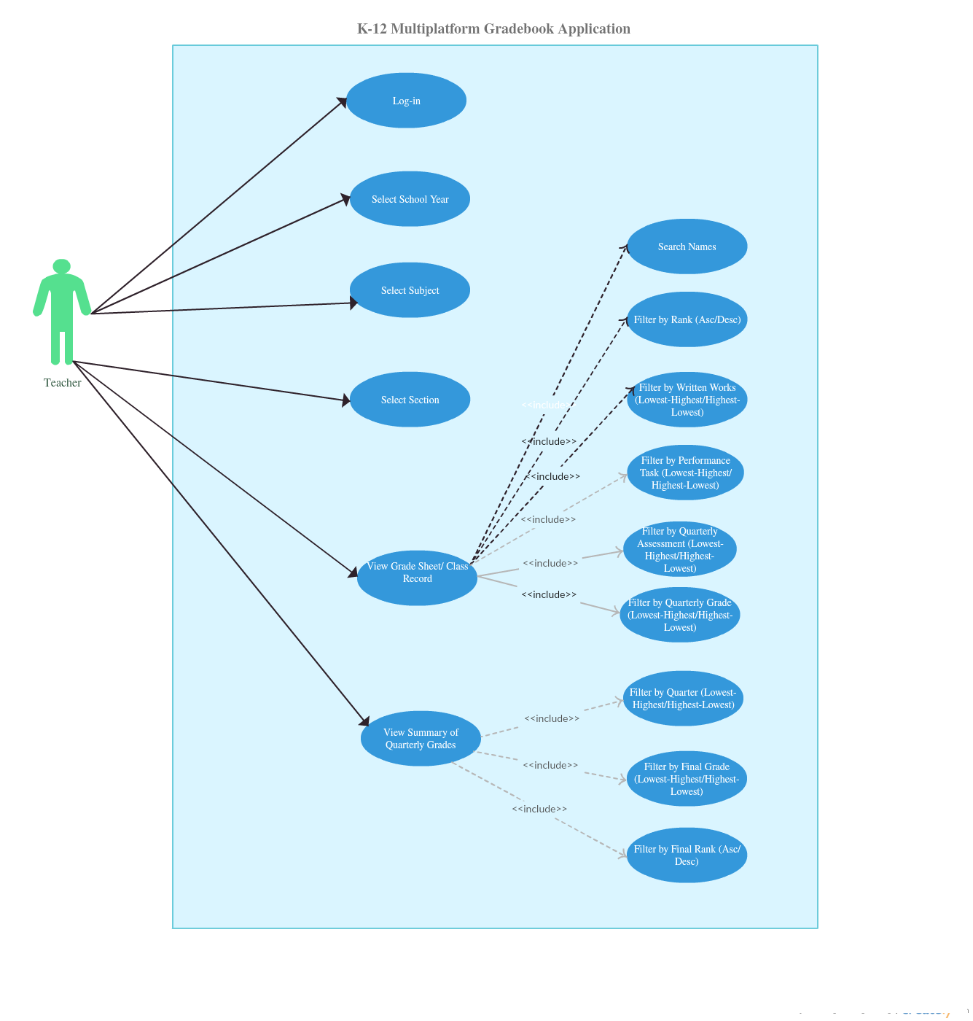

**Figure 2**. Use Case Diagram of K-12 Multiplatform Gradebook Application (Mobile Platform)